**Meeting Contents**

Meeting 1 – 31st January 2020

**We discussed how the game could work: (Our initial ideas)**

* Users will be put into groups based on their personal tutors
  + Split in half – so 5/6 per group
  + One-login per team – so only need one phone
* At the top of the page, there will be blank spaces that make up the final location – hangman style
  + The final location being the building where their tutor is
* There will be a QR Code at each location which students must scan to confirm they are at that particular location
* By scanning the QR code, you will be given a question to answer
  + You may be able to ask for a hint if you are unable to answer it
  + Some questions will be location specific, and others will be generic
* Successfully answering the question will mean a letter from the final location will be given
* The students will have access to all of the locations from the get-go
* There will be a stopwatch from the moment the students scan the first QR code for timing purposes
* Once the team has successfully completed every location, the room of their tutor will be revealed
  + Thus, groups must finish the game before being able to find their tutor
* There will be a real-time leaderboard for the gamekeeper to see, which is based on the number of letters each group has obtained so far
* For the extra information such as FAQs, useful information and room locations in buildings, we could implement it as a chat-box

**We discussed the types of questions we may ask:**

* Cheapest pint in the RAM
* How many seats in a lecture hall

**We discussed the different locations we could use:**

* Library
* Ram
* Forum Auditorium
* Harrison
* 207
* 004
* Sports Park
* Peter Chalk
* Innovation Centre
* Great Hall

Meeting 2 – 3rd February 2020

**We discussed potential “could haves”:**

* Time deduction for a using a hint
* Having team members names as part of a team (could have)

**We discussed the role of the gamekeeper:**

* Gamekeeper has username and password to sign in
* Gamekeeper Functionalities:
  + Gamekeeper can create a game
  + Gamekeeper can only create one game at a time
  + Gamekeeper can print off relevant QR codes for the game
  + Can upload a game file for the relevant subject
  + Can view the leaderboard

**We discussed details of the game from a back-end/database point of view:**

* Each game has a unique gameID
* Team has a unique name within that game
* There will be NO password for each game
* 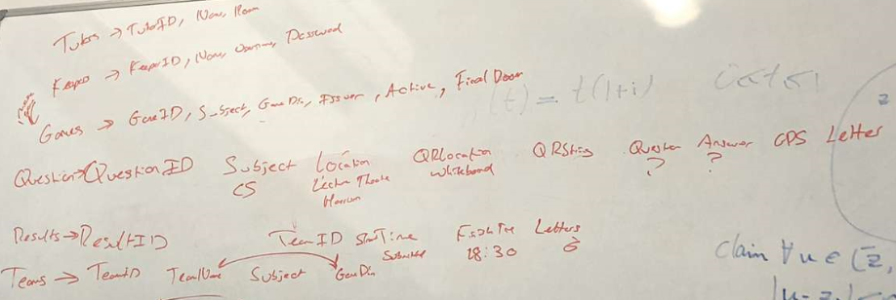We realised we needed to add a number of new tables which we started to generate on a whiteboard

Meeting 3 –7th February 2020

* Updated UI designs
  + FAQs onto the main page because it makes more sense
* Looked at the Kanban board and our progress
* Went through what we have individually done
  + Made sure everyone is on the same page as each other